**Interview Assignment: 04-07-21**

The goal of this assignment is to build a prototype Flipkart with few features

using React JS.

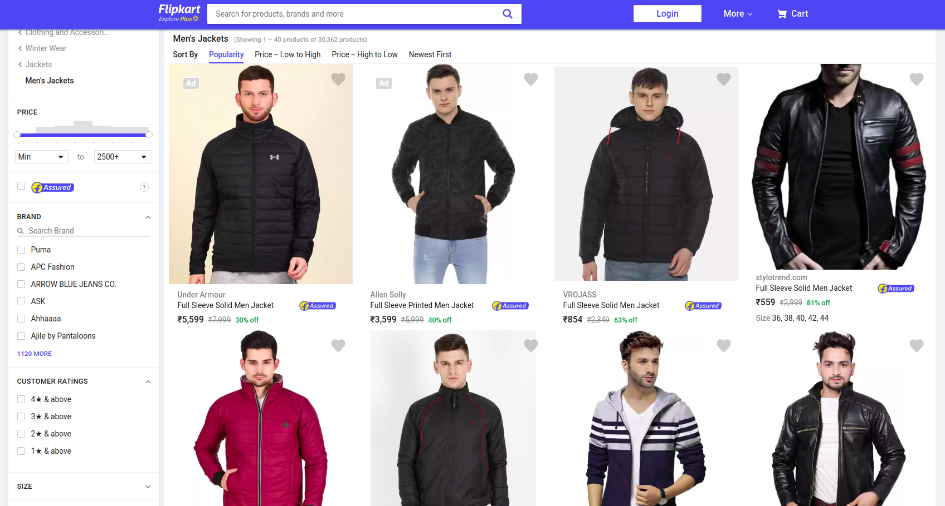

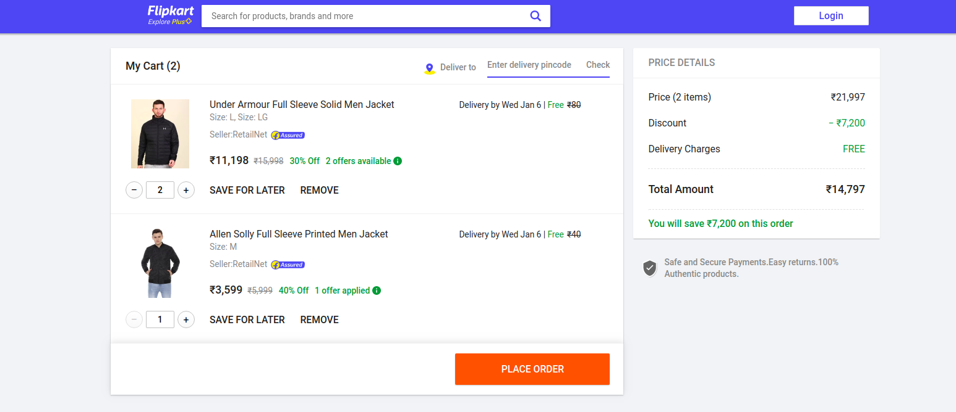

You can refer to [https://www.flipkart.com](https://www.flipkart.com/clothing-and-accessories/pr?sid=clo&otracker=categorytree&p%5B%5D=facets.ideal_for%255B%255D%3DMen&otracker=nmenu_sub_Men_0_Clothing)fordesign ideas and functionality.

**Features to Code:**

1. Create a Flipkart product listing page. A page should contain at least 6 products. It should contain only the products with its details. The sidebar with filters is NOT required to be coded.
2. Create a JSON file for your products data.
3. Create a feature ‘Add to Cart’.
4. You should be able to add as many items in your cart. You can have an ‘Add to Cart’ button for each product listed.
5. The cart page should have following features:
6. Ability to increase quantity of any item
7. Save for Later
8. Remove item
9. Show total Price details with calculated discounts.
10. Show total number of items in cart.

**Guidelines for the interview:**

* For design ideas and functionality: Please refer to <https://www.flipkart.com/clothing-and-accessories/winter-wear/jackets/men-jackets/pr?sid=clo,qvw,z0g,jbm&otracker=categorytree&otracker=nmenu_sub_Men_0_Jackets>
* Please use ReactJS for this problem statement.
* You can use plain CSS or any CSS library you want.
* You will be evaluated on
  + Logic and cleanliness of code.
  + The symmetry of design.
  + Reusable components.
  + Completeness of features.
  + Ability to comprehend and complete features on your own. Looking for thought leadership in the feature area.
* Avoid using Jquery.

Completed all the required functionality. Forgot to remove the arrow within text input.

Time given: 2hours, completed basic implementation in 1hour 55mins.

Github: <https://github.com/supminn/mcr-cart>

Hosted URL: <https://flip-cart.netlify.app/>